|  |  |
| --- | --- |
|  | Foundation Activity 12 Transistor Nightlight |

Contents and Learning Outcomes

Students will build a nightlight circuit using a bipolar junction transistor (BJT) and light dependent resistor (LDR).

This activity should take **~1 hour (1.5 hours recommended)** to complete:

[Materials and Costs per Student 2](#_Toc531547006)

[Lesson 3](#_Toc531547007)

[Activity Overview (5 minutes) 3](#_Toc531547008)

[Bipolar Junction Transistor (BJT) (10 minutes) 3](#_Toc531547009)

[Adding a Transistor to the Nightlight Circuit (10 minutes) 5](#_Toc531547010)

[Build the Circuit (20 minutes) 5](#_Toc531547011)

[Debrief Discussion (10 minutes) 6](#_Toc531547012)

[Challenge and Explore 7](#_Toc531547013)

[Frequently Asked Questions 8](#_Toc531547014)

Materials and Costs per Student

Assuming one kit of parts per student:

|  |  |  |  |  |
| --- | --- | --- | --- | --- |
| Item | Qty. | Cost per Student[1](#fn:1) | Expendable[2](#fn:2) | Supplier |
| LED, 5mm, white | 1 | 0.02 | y | AliExpress |
| Resistors, 1/4 W, Assorted | 2 | 0.01 | y | AliExpress |
| 9V Battery Snap | 1 | 0.16 |  | AliExpress |
| Jumper cables, MM, 10cm | 6 | 0.12 | y | AliExpress |
| Light Dependent Resistor (LDR) | 1 | 0.05 |  | AliExpress |
| Breadboard 400 point | 1 | 1.49 |  | AliExpress |
| Breadboard Power Supply, 5V/3.3V | 1 | 0.75 |  | AliExpress |
| BJT, NPN, PN2222 | 1 | 0.10 | y | AliExpress |
| 9V Ni-Mh 450mAh | 1 | 5.17 |  | AliExpress |
| Total Cost per Student |  | **$7.87 CAD** |  |  |

1. *Currency is CAD, 2017-06-10. Assuming one set of parts per student.*
2. *Likely to be broken or lost during the activity.*

Each student should also get one printed copy of the activity handout.

If running the activity in a room with daylight, I recommend using a 22kΩ resistor in the voltage divider. If running the activity in a fluorescent lit room, use a 100kΩ or 220kΩ resistor in the voltage divider; 220kΩ is used below, but 100kΩ is preferable. This will also depend on your LDR. The one used in this activity behaves as follows:

|  |  |  |
| --- | --- | --- |
|  | LDR Resistance | |
|  | **LDR Uncovered** | **LDR Covered with a Finger** |
| Daylight | 2.2kΩ | 20kΩ |
| Dusk | 10kΩ | 40kΩ |
| Fluorescent Lighting | 10kΩ | >50kΩ |

Experiment with the resistor values before the lesson to make sure the nightlight works in your light conditions. Having a bright LED flashlight in class to manipulate the LDR resistance is also advisable.

Lesson

**Bold text** indicates directions or notes specifically for the instructor.

Activity Overview (5 minutes)

|  |  |
| --- | --- |
| In the last activity we used a light dependent resistor (LDR) in a voltage divider to automatically turn an LED on when the room becomes dark and off when the room becomes bright. **(draw the diagram on the board)**  There was an issue with this circuit though. What was the problem? A: the LED is dim, because the current must flow through the large 22kΩ resistor. | C:\Users\Harryp\MEGA\Surface Pro 2\Nepal\Himalayan Makers Guild\Activities\Foundation Activities\FA12 - Transistor Nightlight\images\Eagle\nightlight_on_current.png |
| However, if we could connect the LED to 5V through a small 220Ω resistor and button, it would turn on brightly when we press the button. **(draw the diagram on the board)** Then, if we have some sort of button that, instead of pressing it with our finger, we could control it with Vout from the LDR voltage divider we would get a nice bright light that is also automatically controlled! | C:\Users\Harryp\MEGA\Surface Pro 2\Nepal\Himalayan Makers Guild\Activities\Foundation Activities\FA12 - Transistor Nightlight\images\Eagle\nightlight_button2.png |

Today, we’re going to:

1. Learn about bipolar junction transistors (BJTs), one type of voltage-controlled switch.
2. Build an improved nightlight circuit using the BJT.

Bipolar Junction Transistor (BJT) (10 minutes)

There are many different types of transistors, but today we’re going to look at an NPN Bipolar Junction Transistor (BJT).

How many pins do you think a BJT has?  
A: It has 3 pins. Just like a switch, there are two pins that become connected when the BJT is on. There is also a 3rd pin that controls whether current will flow between the two pins. The three pins are called the Collector (C), Base (B), and Emitter (E). **(Draw the diagram and part image on the board)**

|  |  |
| --- | --- |
| Circuit Symbol | Part Image |
| C:\Users\Harryp\MEGA\Surface Pro 2\Nepal\Himalayan Makers Guild\Activities\Foundation Activities\FA12 - Transistor Nightlight\images\bjt_pins.png | **C:\Users\Harryp\MEGA\Surface Pro 2\Nepal\Himalayan Makers Guild\Activities\Foundation Activities\FA12 - Transistor Nightlight\images\bjt_pinout.png[[1]](#footnote-1)** |

Current flows from C to E, and is controlled by the voltage between B and E (V\_BE). Similarly to how we need 3V to turn on a white LED, the BJT only turns on when V\_BE is greater than 0.6V.

|  |  |
| --- | --- |
| When V\_BE is less than 0.6V, the BJT is like an open switch and now current will flow. **(draw the diagram and part image on the board)** | When V\_BE is greater than 0.6V, the BJT is like a closed switch and current can flow from C to E. V\_BE will stay quite constant (around 0.7V), so here we can represent it as a diode. |
| C:\Users\Harryp\MEGA\Surface Pro 2\Nepal\Himalayan Makers Guild\Activities\Foundation Activities\FA12 - Transistor Nightlight\images\Eagle\bjt_off.png | C:\Users\Harryp\MEGA\Surface Pro 2\Nepal\Himalayan Makers Guild\Activities\Foundation Activities\FA12 - Transistor Nightlight\images\Eagle\bjt_on.png |

Actually, when the BJT is on (V\_BE > 0.6V) the amount of current that is able to flow from C to E depends on the current flowing from B to E. It is not a perfect on/off switch.

|  |  |
| --- | --- |
| The amount of current that can flow C to E is about 100 times the current flowing from B to E. | If more current flows from B to E, the amount of current that is able to flow C to E increases. |
| C:\Users\Harryp\MEGA\Surface Pro 2\Nepal\Himalayan Makers Guild\Activities\Foundation Activities\FA12 - Transistor Nightlight\images\Eagle\bjt_on2.png | C:\Users\Harryp\MEGA\Surface Pro 2\Nepal\Himalayan Makers Guild\Activities\Foundation Activities\FA12 - Transistor Nightlight\images\Eagle\bjt_on3.png |

Like an LED, too much current flowing from B to E can damage the BJT, so we need to make sure there is a resistor attached to B. However, if that resistor is too high we may not get as much current flowing from C to E as we’d like.

**Note: For more advanced students, it is helpful to look at the datasheet for the NPN transistor (in our case the** [**PN2222A**](https://cdn-shop.adafruit.com/datasheets/PN2222A.pdf)**[[2]](#footnote-2)) and highlight important points: the pin-out on page 1 and the turn-on voltage VBE(sat) and current gain hFE on page 2.**

Adding a Transistor to the Nightlight Circuit (10 minutes)

|  |  |
| --- | --- |
| To add the BJT in the nightlight circuit, we should connect E to ground, and C to the negative pin of the LED. **(draw the diagram on the board)** This way, we only need to get B up to 0.6V to turn the light on.  Since the voltage of B controls whether the light is on or off, we connect it to Vout from the voltage divider. | C:\Users\Harryp\MEGA\Surface Pro 2\Nepal\Himalayan Makers Guild\Activities\Foundation Activities\FA12 - Transistor Nightlight\images\Eagle\nightlight_bjt_R.png |
| In the last activity, we wanted Vout to reach 3V when the LDR resistance increased in a dark room. Now we only need 0.6V to turn on the BJT and allow current to flow through the LED. To lower Vout should we make the top resistor in the voltage divider (R) bigger or smaller than the 22kΩ we used in the previous nightlight activity? A: The resistor should be bigger so that more voltage is dropped across the top resistor, lowering Vout. **(draw 220kΩ into the diagram)** | C:\Users\Harryp\MEGA\Surface Pro 2\Nepal\Himalayan Makers Guild\Activities\Foundation Activities\FA12 - Transistor Nightlight\images\Eagle\nightlight_bjt.png |

Build the Circuit (20 minutes)

**Distribute the parts to the students and have them try building the circuit.**

Debrief Discussion (10 minutes)

Today we used a BJT and LDR to automatically switch an LED on and off, depending on the room brightness. What advantages does this have over the nightlight from the last activity?

* A1: Current flows through only the 220Ω resistor, so the LED can light up at full brightness when the BJT is switched fully on.
* A2: There is more total resistance in the voltage divider, so less current will be constantly draining through the voltage divider. Because of this, a battery powering the circuit should last longer!

|  |  |
| --- | --- |
| Did anyone notice that the light still doesn’t turn on at full brightness? If we attach a button in parallel with the BJT, and compare the LED brightness when pressing the button to the LED brightness when current is flowing through the BJT, we can see that the LED lights up brighter when using the button! Can anyone guess why this is?  A: This is because the maximum current that can flow through the BJT from C to E is limited by the current flowing from B to E. How much current is flowing from B to E? Very little, since it must flow through the 220kΩ resistor before entering the BJT. | C:\Users\Harryp\MEGA\Surface Pro 2\Nepal\Himalayan Makers Guild\Activities\Foundation Activities\FA12 - Transistor Nightlight\images\Eagle\nightlight_bjt_b2.png |

Still, the circuit did give an improvement in brightness and less battery drainage through the voltage divider compared to our first attempt at the LED circuit.

What could we do next, or how could we make the circuit better? **Some ideas include:**

* Use a potentiometer in the voltage divider so that the sensitivity of the nightlight can be adjusted
* Add a switch to be able to turn off the nightlight when the room is dark.
* Make the LED turn on brighter by increasing the current to the BJT by lowering the total resistance of the voltage divider (at the expense of a shorter battery life).

Challenge and Explore

**If a student completes the lesson early, evaluate their understanding by asking them to try the following:**

* Add a button so that the button must be pressed for the night-light to work.

*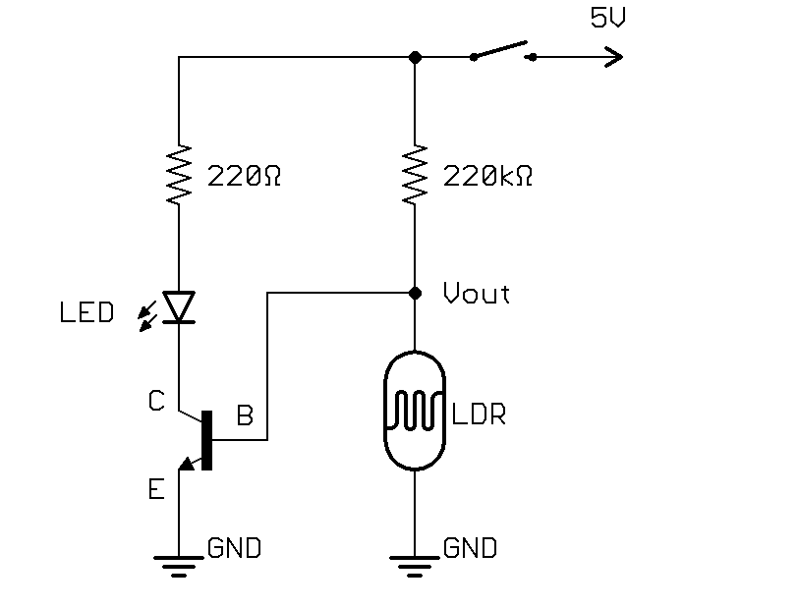*

* Add a button so that the night light works as usual, but if the button is pressed the LED turns on.

*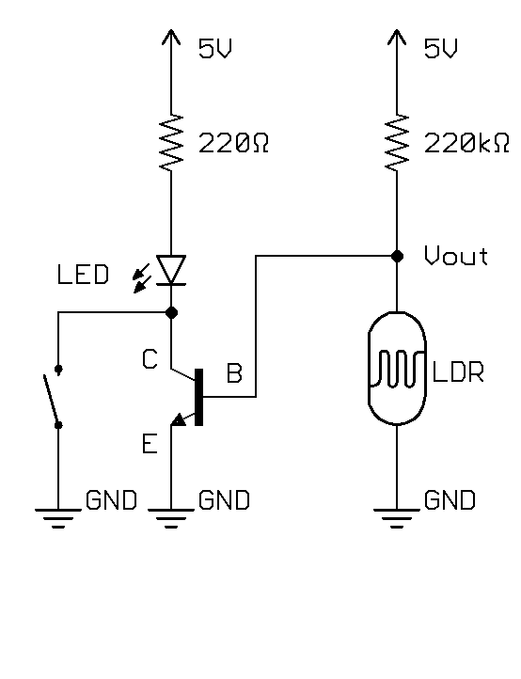*

* How many nodes are in the nightlight circuit?  
  A: 5.

*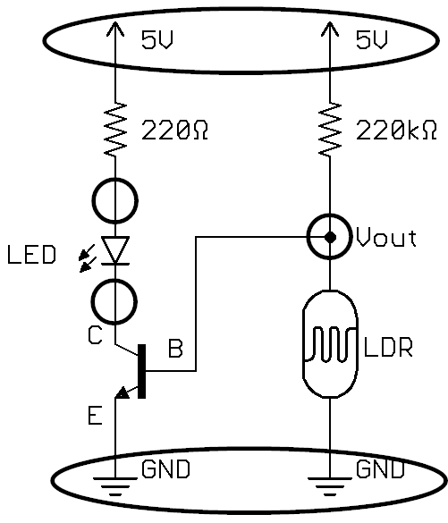*

Frequently Asked Questions

* It’s working, but the LED doesn’t look that bright.   
  A: make sure that the BJT is oriented correctly, with the Emitter connected to ground. If it’s connected the other way around (with the collector attached to round) it will still act as a switch but conduct poorly in the “on” state.
* The student thinks the circuit isn’t working because the light isn’t turning on.  
  A1: clarify that in a bright room, we want the light off. To imitate being in a dark room, the student should cover the LSR with their finger, then the LED should turn on.  
  A2: check the polarity of the LED and make sure that the (+) side is connected towards the Arduino pin, and (-) is connected to GND.   
  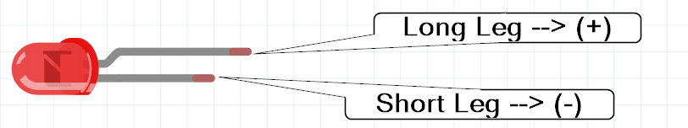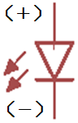
* The LED is on all the time, and just changes brightness when the LSR is covered (gets brighter).  
  A: The resistor in the voltage divider may be small for the light conditions of the room, so the voltage never gets low enough to switch the light off. Try increasing the resistance.
* Circuit looks good, LED polarity is correct, but it’s still not working.  
  A1: Make sure the power supply is on and on the breadboard in the correct direction with the (-) from the power supply on the blue line of the breadboard:  
  CORRECT:  
  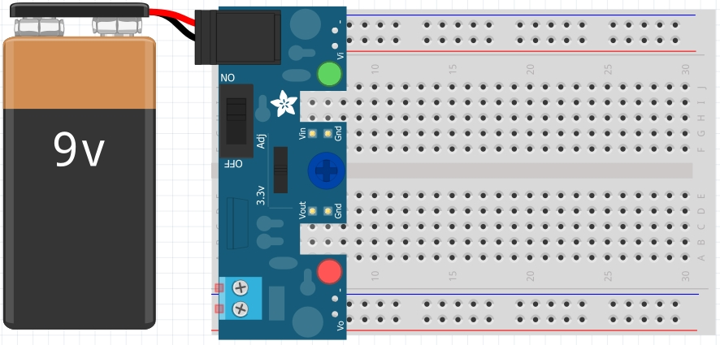
* INCORRECT:  
  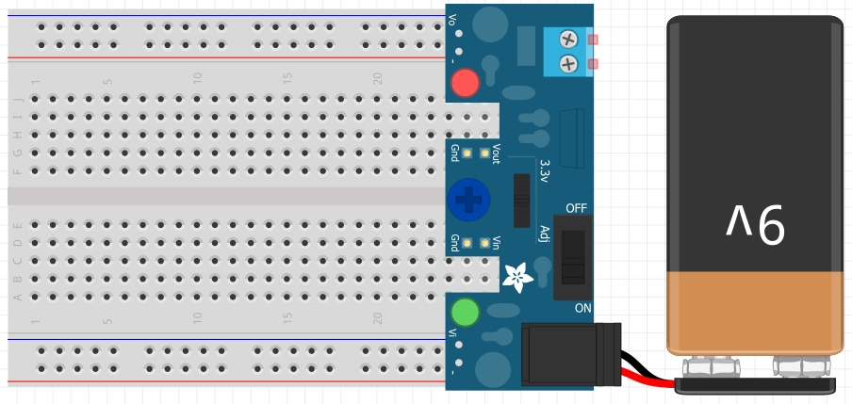  
  A2: check to make sure the LED isn’t burnt out by trying it in a friend’s circuit that is already working.  
  A3: the resistor in the voltage divider may be too large for the light conditions of the room, and the voltage in the divider is not rising high enough to switch on the light. Try a smaller resistor value in the voltage divider (put a 2nd 220kΩ resistor in parallel with the first to lower the total resistance to 110kΩ).

1. Part image from Fritzing. [↑](#footnote-ref-1)
2. https://cdn-shop.adafruit.com/datasheets/PN2222A.pdf [↑](#footnote-ref-2)